WDSC 2018 LONG COURSE SPRINT MEET
(Under A.S.A Law & Technical Rules)
(LEVEL 3) License Number: 3SE180758
WYCOMBE LEISURE CENTRE, HIGH WYCOMBE, BUCKS, HP11 1UP
Sat Nav HP11 1TJ
(Close to Junction 4 on M40)

Saturday 28th April 2018

ANTI - WAVE LANE ROPES | 8 LANE 50M POOL | ALL EVENTS HDW
Omega Timing with OBS11 Wedge Blocks

ENTRIES ARE FIRST COME FIRST SERVED

Closing Date: 31st March 2018 | Entry fee: £7.00 per event
Ages at 28th April 2018

Age Groups
Girls 9yrs 10yrs 11yrs 12yrs 13yrs 14yrs 15yrs 16yrs 17+over
Boys 9yrs 10yrs 11yrs 12yrs 13yrs 14yrs 15yrs 16yrs 17+over

50m & 100m Events

Top Visiting Club, Top Male Swimmer & Top Female Swimmer Awards

For further details please visit: www.wycombe-swimming.org.uk
Meet Promoter: Simon Shaw

Meet Secretary: Jeremy Butler
Contact details: E: openmeets@wycombe-swimming.org.uk

SCHEDULE OF EVENTS

SATURDAY
SESSION 1 - Warm up 08:00 Start 08:50
1 | G | 50 | BACK |  | 9, 10, 11, 12, 13,14, 15, 16, 17+
2 | B | 50 | FLY |  | 9, 10, 11, 12, 13,14, 15, 16, 17+
3 | G | 100 | BREAST |  | 9, 10, 11, 12, 13,14, 15, 16, 17+
4 | B | 100 | BACK |  | 9, 10, 11, 12, 13,14, 15, 16, 17+
5 | G | 100 | FREE |  | 9, 10, 11, 12, 13,14, 15, 16, 17+
SESSION 2 – Warm up TBC Start TBC
6 | B | 50 | BREAST |  | 9, 10, 11, 12, 13,14, 15, 16, 17+
7 | G | 50 | FLY |  | 9, 10, 11, 12, 13,14, 15, 16, 17+
8 | B | 50 | FREE |  | 9, 10, 11, 12, 13,14, 15, 16, 17+
9 | G | 100 | BACK |  | 9, 10, 11, 12, 13,14, 15, 16, 17+
10 | B | 100 | FLY |  | 9, 10, 11, 12, 13,14, 15, 16, 17+
SESSION 3 – Warm up TBC Start TBC
11 | G | 50 |  | BREAST | 9, 10, 11, 12, 13,14, 15, 16, 17+
12 | B | 50 |  | BACK | 9, 10, 11, 12, 13,14, 15, 16, 17+
13 | G | 50 |  | FREE | 9, 10, 11, 12, 13,14, 15, 16, 17+
14 | B | 100 |  | BREAST | 9, 10, 11, 12, 13,14, 15, 16, 17+
15 | G | 100 |  | FLY | 9, 10, 11, 12, 13,14, 15, 16, 17+
16 | B | 100 |  | FREE | 9, 10, 11, 12, 13,14, 15, 16, 17+

Note: Timings may be updated closer to the meet after entries are finalised.
Refer to the Wycombe Swimming website for latest updates.

QUALIFICATION TIMES (NOT-FASTER-THAN)

- Qualifying times are shown as ‘Not Faster Than’ times.
- Entry times SHOULD BE either LONG COURSE TIMES or converted to LONG COURSE.
- Entry times to be achieved within last 12 months.

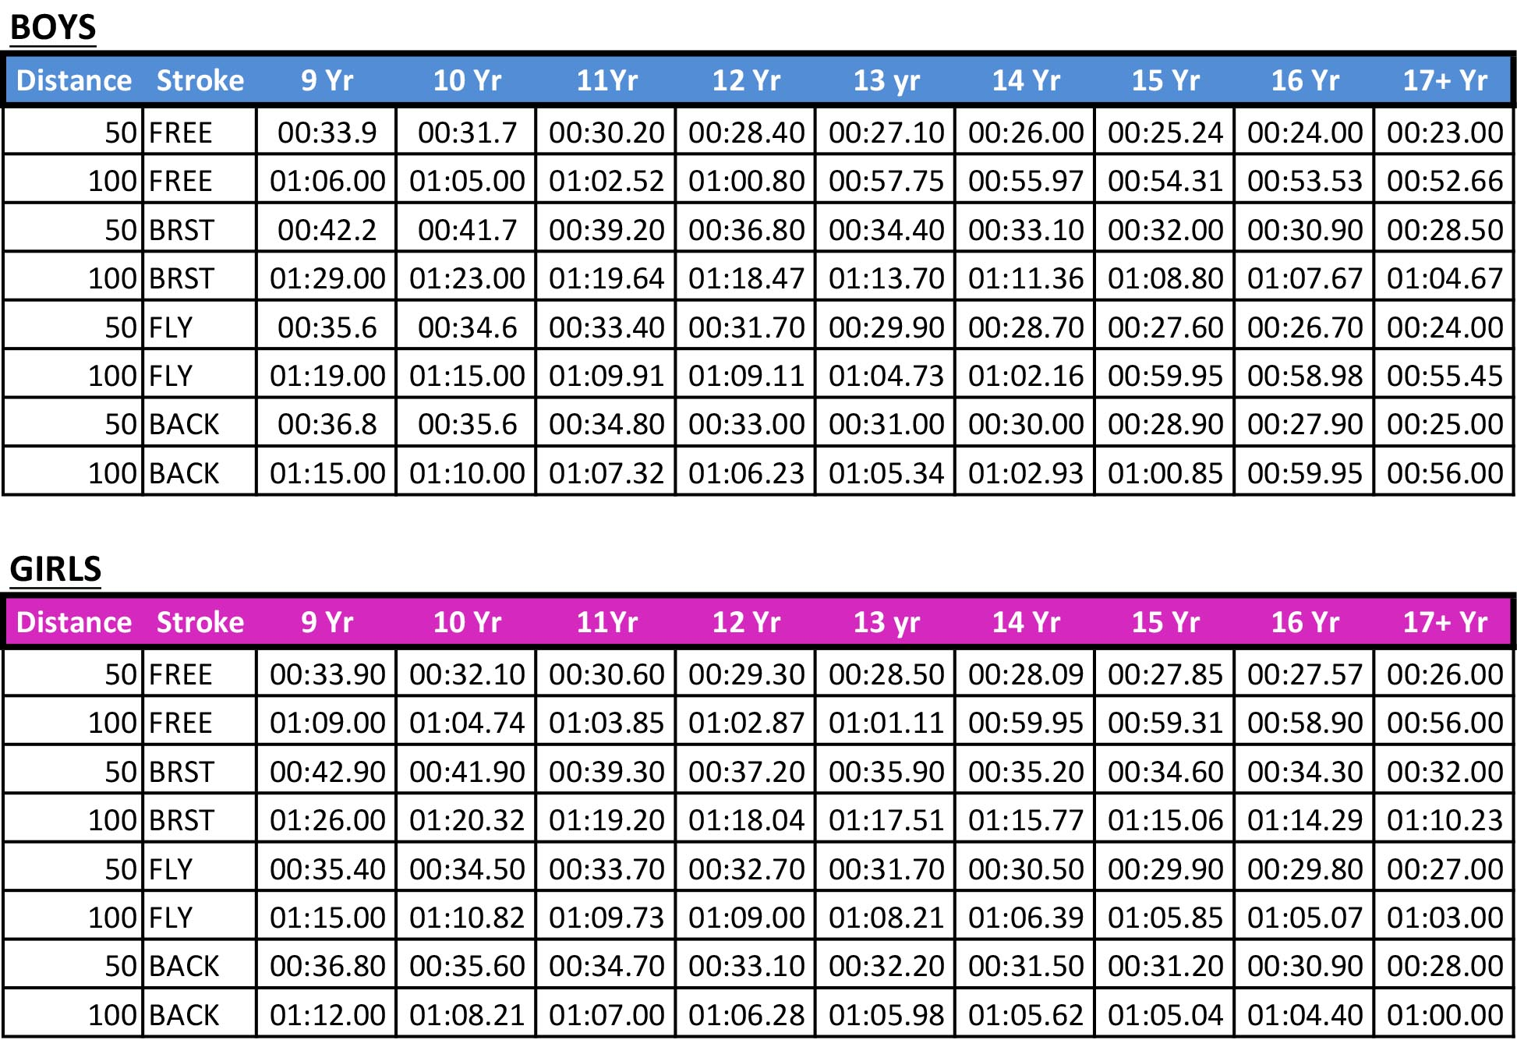

Competition Rules and Information

The competition will be held under A.S.A Law & Technical Rules.

LENGTH OF POOL
The Pool is 50 metres long and eight lanes, anti-turbulence lane ropes will be used. Electronic time keeping will be used.

A swim down pool will be available throughout the meet.

ENTRY PROCEDURE
Entry should be made by submitting the Hy-Tek file available at:
http://www.wycombe-swimming.org.uk
(Team manager lite is available to download at: http://www.hy-tekltd.com/downloads.html ).

Manual Entry forms are also available with the pack.
http://www.wycombe-swimming.org.uk and should be returned to: Meet Secretary (there is a £5 supplement per swimmer for manual entries).

Entry fees should be paid by BACs payments: RBS; Sort code: 162129; Account number: 10104974, PLEASE USE REFERENCE – WDSCSPRINT followed by your club code.
Cheques are accepted and need to be made payable to: Wycombe District Swimming Club and crossed and sent to the Meet Organiser.

ENTRIES:
Entries are open from 5 February 2018 and close on 31 March 2018. In the event of the Meet being oversubscribed entries will be accepted on a first come first served basis.
Send Entries (including coach passes and official forms) to: openmeets@wycombe-swimming.org.uk
Accepted Entries will be published no later than on 4 April 2018.
Hy-Tek file available for electronic entries: www.wycombe-swimming.org.uk

The Event will be swum as a CARDLESS event therefore swimmers are asked to SIGN in before EACH session and before warm up starts.
Competitors must be registered swimmers.

No entries will be accepted without the appropriate entry fee; submitted time; ASA registration.
For all enquiries please contact the Meet Secretary, contact details on page 1.

Any swimmer withdrawing prior to the closing date will receive a full refund. After the closing date and up to the day before the gala refunds can only be provided on receipt of proof of injury through a doctor’s certificate.

CLOSING DATE FOR ENTRIES
31st MARCH 2018

ENTRY TIMES
Entry times SHOULD BE either LONG COURSE TIMES or converted to LONG COURSE.
Entry times to be achieved within last 12 months.
Poolside entries will only be accepted as time trials and are at discretion of Meet Promoter.
All events will be seeded on submitted times.

AWARDS
Medals will be given to the first three swimmers in each Age Group.
Awards are to be collected from the medal table after the results have been posted.
Individual Awards will be made on an HDW basis.
Swimmers must ensure that they are suitably clothed (tee shirt, shorts, foot-ware, etc.) when collecting awards.

Top visiting club will receive an award.

OFFICIALS
To ensure the Meet can run effectively and efficiently WDSC encourage all clubs to help where possible with officials. Please send the officials form in with your entry.

MEET RESULTS
Meet results will be posted on the Wycombe District Swimming Club website within 48 hours of the Meet closing.
An electronic copy of the Meet clubs results will be sent to individual clubs on request from a club official.
Results will be passed to the ASA for their reference and inclusion in rankings.

SPECTATORS
Entry £5.00 per individual session (concessions available) or £10 for an all day pass (no concessions).
Programs will be available to purchase on day of the Meet.
For the safety and welfare of all swimmers, spectators and parents are NOT allowed poolside or in the changing rooms during the Meet.

CAR-PARKING
‘Pay and Display’ car parking is available at the Leisure Centre. At the time of publishing, parking at the ‘Park and Ride’ (2 minutes walk from the pool) is free. Please check on the Wycombe Swimming website closer to the event for any updates.

REFRESHMENTS
The Leisure Centre has a small cafe that will be in operation throughout the meet. The adjacent Waitrose supermarket also has a large cafeteria. Food may not be taken onto poolside.
There will be refreshments and lunch provided for coaches who have purchased a Coach pass.

HEALTH AND SAFETY
No outdoors shoes to be worn on the poolside. No large bags are allowed poolside.

Swimmers are asked to ensure they wear appropriate footwear and clothing when on the balcony or reception area.

The pool depth is 2m and the blocks are 75cm above the edge. If you are unable to execute a competent racing dive do not use the starting blocks at any time during this swim Meet. A competent racing dive is defined as in the ASA Competitive start award; each swimmer is required to hold one of these. It is the Coach and/or Team Managers responsibility to ensure that this is the case for all swimmers intending to execute a racing dive. No swimmer should topple into the water in the event of a false start - a proper shallow dive must be performed.

Further event information including any health and safety guidance resultant from our risk assessments will be made available to participants closer to the event. Please ensure you read the information and utilise for your club planning and risk assessment.

POOLSIDE ACCESS PASSES
Passes are required for all non-swimmers accessing poolside or changing rooms and may be picked up from the sign-in desk before entering the pool. This includes all coaches, Team managers and chaperones. Passes are required for each individual in a session; if different people are attending different sessions, then passes may be transferred but the DBS details of each individual must have been supplied with the Coach/Chaperone Application in the entry pack. Each pass includes one lunch, meet programme and poolside refreshments.

Heat Sheets will only be provided to officials, coaches and team managers displaying passes.

DATA PROTECTION
Entries and results for this Meet will be held on computer. As required by the Data Protection Act 1998, submission of entries implies consent to the holding of personal information on computer. These details may be made public before, during or after the Meet.

PARA- SWIMMERS
Swimmers with classifications (S Categories) and those who require additional provisions to access the event are requested to notify the meet promoter in advance of the meet.

FILMING AND PHOTOGRAPHY
Anyone who wishes to take images are requested to focus on their own children as much as reasonably possible and to avoid including other children in images, particularly if those images are being shared with family and friends or through social media platforms. Whilst it is acknowledged that parents/carers wish to celebrate the achievements of their own children when taking part in aquatic events, it should be recognised and respected that other parents/carers may not wish for their child’s image to be taken and shared in this way.
The use of cameras or mobile phones for taking photographs in the changing area is strictly forbidden. Only coaches and team managers may take photos or film races on poolside and these must comply with Swim England guidance and the focus of the filming should be of their swimmers only. Any swimmer or coach found to be breaking these rules will be asked to leave the building and will take no further part in the competition. The club also reserves the right to take further action against anybody breaking this rule.
The safety of children and young people for this event is of paramount importance. If you have any child safeguarding concerns at the event, please contact the meet coordinator.

SWIM SHOP
A Mailsports Swim Shop will be in operation throughout the Meet.

APPEALS
Any appeals must be submitted in accordance with ASA procedures and will be handled by the Meet Promoter and Referees.

GENERAL
Any point not covered by these rules will be at the discretion of the Meet Promoter. Depending upon the situation, the Meet Promoter or Referees decision, respectively, will be final.

OFFICIALS APPLICATION FORM

Please complete details:

CLUB NAME
Name
Qualification (J1, J2 etc.)
License Number
Email
SESSION Availability (please tick)
Session | 1 |  | 2 |  | 3
Name
Qualification (J1, J2 etc.)
License Number
Email
SESSION Availability (please tick)
SESSION | 1 |  | 2 |  | 3
Name
Qualification (J1, J2 etc.)
License Number
Email
SESSION Availability (please tick)
SESSION | 1 |  | 2 |  | 3

PLEASE RETURN THIS FORM TO: Meet Secretary
PLEASE ENSURE THIS FORM IS SUBMITTED WITH YOUR CLUB ENTRY

COACH / CHAPERONE APPLICATION

Coach / Chaperone passes cost £30.00 for the weekend per individual and include poolside access, lunch each day and poolside refreshments.

Please complete details for each pass application:

 | APPLICATION #1 | APPLICATION #2 | APPLICATION #3
FULL NAME
NAME OF CLUB
POSITION AT CLUB
e.g. Coach, Team Manager
ADDRESS
POSTCODE
TELEPHONE
EMAIL ADDRESS
ASA NUMBER
DBS CHECK NUMBER

PLEASE RETURN THIS FORM TO: Meet Organiser
PLEASE ENSURE THIS FORM IS SUBMITTED WITH YOUR CLUB ENTRY

SWIMMER MANUAL ENTRY FORM - FEMALE

FEMALE ENTRY  Circle the event you want to enter |  | SURNAME
 |  | FIRSTNAME
 |  | DATE of Birth
 |  | ASA Number
 |  | Club
EVENT # | DISTANCE | STROKE | ENTRY TIME
1 | 50 | BACK
3 | 100 | BRST
5 | 100 | FREE
7 | 50 | FLY
9 | 100 | BACK
11 | 50 | BRST
13 | 50 | FREE
15 | 100 | FLY
Please note there is a £5 supplement per swimmer for manual entries

SWIMMER MANUAL ENTRY FORM – MALE

MALE ENTRY  Circle the event you want to enter |  | SURNAME
 |  | FIRSTNAME
 |  | DATE of Birth
 |  | ASA Number
 |  | Club
EVENT # | DISTANCE | STROKE | ENTRY TIME
2 | 50 | FLY
4 | 100 | BACK
6 | 50 | BRST
8 | 50 | FREE
10 | 100 | FLY
12 | 50 | BACK
14 | 100 | BRST
16 | 100 | FREE
Please note there is a £5 supplement per swimmer for manual entries

CLUB ENTRY INFORMATION SUMMARY
CLUB NAME
CONTACT NAME
ADDRESS

TELEPHONE (DAY)
TELEPHONE (EVENING)
MOBILE PHONE
EMAIL
PLEASE USE REFERENCE WDSCSPRINT followed by your club code or name FOR ANY BACS PAYMENTS
Manual Entries: Wycombe District Swimming Club, Wycombe Leisure Centre, Handy Cross, High Wycombe, HP11 1UP. (Please email a scanned copy)
Enquiries can be emailed to openmeets@wycombe-swimming.org.uk
Cheques made payable to ‘Wycombe District Swimming Club’
Electronic entries can be e-mailed but please email a scanned copy of this form
TOTAL ENTRIES |  |  | @ £7.00 EACH = £
Manual entry supplement per swimmer £5 |  |  | = £
Coaches / Poolside Packs |  |  | @£15 EACH = £
TOTAL |  |  | £
PAYMENT MADE BY  (delete as appropriate) |  | BACS |  | CHEQUE ENCLOSED
I certify that all the above details are correct and that our Club understand and will abide by the meet conditions. Signed on behalf of all swimmers:
WDSC Bank Details
RBS; Sort code: 162129; Account number: 10104974

SIGNATURE………………………………………………………………..

